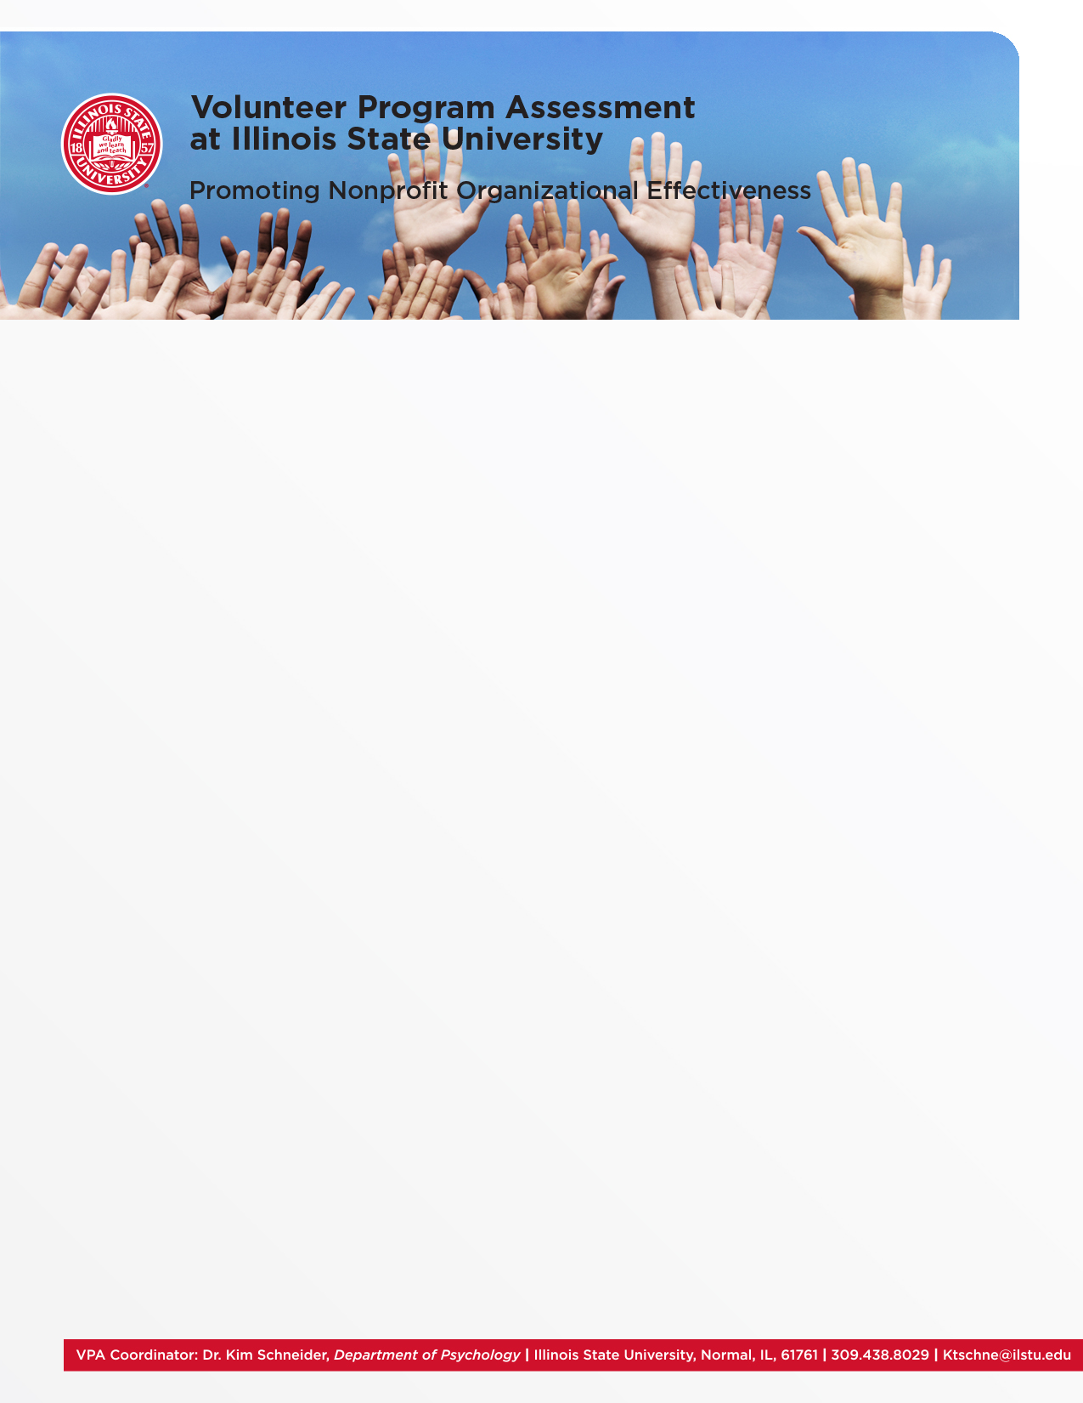

**Overview of the VPA**• Free Volunteer Assessment   
• Help leaders understand strengths and weaknesses  
of their volunteer program   
• Offer insights on the strategic management of volunteer resources

**The VPA Process**   
The VPA is an online survey assessing volunteers’ opinions of their agency. Our team works with the Volunteer Coordinator to send the survey to the agency’s volunteers. The Illinois State University VPA consultants will then analyze the results of the VPA survey and will provide a feedback report to the agency or organization. We also provide summaries of open-ended responses made by your agency volunteers related to the program’s strengths and areas for improvement.

**Normative Comparisons with Other Nonprofit Agencies and Organizations**In addition to individual agency results, VPA provides Volunteer Coordinators with normative data from surveys by hundreds of organizations completed since 2009. This data provides insights to typical challenges that volunteer programs may experience.

**The VPA Survey**   
The survey focuses on the following concepts:   
• Job Satisfaction   
• Satisfaction with Communication  
• Volunteers’ Perception of Voice and Input   
• Organizational Commitment   
• Organizational Constraints  
• Stress and Burnout

**How to Get Your Organization Involved**   
Partner agencies and organizations are provided all resources free of charge due to our emphasis on providing VPA as a training resource for our graduate students. If you are interested in VPA, please contact Dr. Kim Schneider at [ktschne@ilstu.edu](mailto:ktschne@ilstu.edu) or   
(309) 438-8029

**Student Involvement**   
Graduate students from Illinois State University’s Department of Psychology, along with undergraduate students, volunteer their time to support VPA. Since 2012, nearly 30 different students have been a part of VPA at ISU; for the 2015- 2016 academic year, VPA has 6 active consultants.

Students manage the VPA process, which includes:   
• Scheduling the survey   
• Managing the online survey platform   
• Generating survey result reports   
• Leading a consultation call to present survey results

**Partner Universities**   
The VPA program at Illinois State University has partnered with other universities across the U.S. Each of these universities has a graduate training program in Organizational Psychology. Our partners are George Mason University, Creighton University, the University of North Carolina Charlotte, the University of South Florida, and Northern Illinois University.

**Past VPA Clients**   
We have worked with a variety of agencies and organizations, including hospitals, police departments, and animal shelters. Our partner universities have also worked with social service agencies.

*Clients include:*Barnes-Jewish Hospital (St. Louis, MO)  
Seattle, WA Police Department   
Phoenix, AZ Police Department   
Birmingham, AL Police Department  
Homeward Pet Adoption Center (Seattle, WA)  
Animal Care and Control of NYC   
MEOW Cat Rescue (Seattle, WA)   
Boulder Valley Humane Society (Boulder, CO)   
Habitat for Humanity Omaha   
Big Brothers Big Sisters of the Midlands  
Cystic Fibrosis Foundation   
Catholic Charities  
Dress for Success Worldwide (Los Angeles, CA)