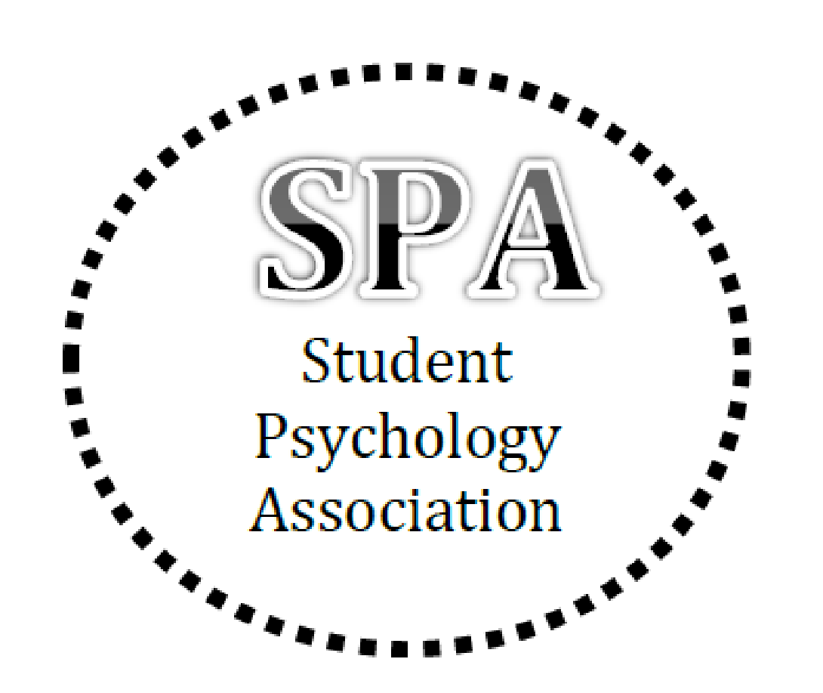
Student Psychology Association
Spring 2022 Application
(Due February 17th, 2022)
Name: _________________________________________________________
Local Phone #: __________________________________________________
Email (ISU): ____________________________________________________
Year in School: ☐Freshman ☐Sophomore ☐Junior ☐Senior
New Member: ☐Yes ☐No, I have been in SPA before
Plans after graduation:
______________________________________________________________
Particular interest in psychology:
______________________________________________________________
Ideas for meeting topics:
______________________________________________________________
Please return this form to the treasurer (kmrokus@ilstu.edu) with your plan for dues of:
☐$20 for one semester ☐$40 for one year
Please make checks payable to Psi Chi Student Psychology Association
or send on Venmo to @PsiChi SPA
Check mark box for T-shirt size (cost included in application fee)
Small Medium Large X-Large XX-Large
Check mark box for T-shirt color:

Black White

