Psy 480: Animal Cognition
Fall 2020
Dr. Val Farmer-Dougan

Discussion Questions for Week 1.

- Using Darwin’s theory-who is most likely to survive the current pandemic and why?
- So, are organisms always learning? Is learning, then, an important evolutionary behavior?
- Perkins and Kindle share 55% of their DNA. Take a look at their pictures on the next page. They obviously look and behavior VERY differently. Why?
- Reviewing Thorndike’s laws: Do these theories just apply to animals, or do these theories appear in more modern psychological theories about humans?
- Do you agree with Morgan’s cannon: KISS? Do you think the scientific world abides by KISS?
- How does this quote from Thorndike explain the current tug-of-war between politics and science?
“The welfare of mankind now depends on the sciences of man. The sciences of things will, unless civilization collapses, progress, extend man’s control over nature, and guide technology, agriculture, medicine, and other arts effectively. They will protect man against dangers and disasters except such as he himself causes. He is now his own worst enemy. Knowledge of psychology and its applications to welfare should prevent, or at least diminish, some of the errors and calamities for which the well-intentioned have been and are responsible. It should reduce greatly the harm done by the stupid and vicious
- A dog repeatedly barks when the mailman appears at the door. What, exactly, is the FUNCTION for barking at the mailman?
  - Do all dogs bark at the mailman?
  - When does barking appear in a dog’s development? When does specifically barking at a mailman appear?
  - How might barking at the mailman change a dog’s brain.
- Clive Wynne obviously studies dogs. Why are dogs such good research subjects?
- Why do dogs love us? What about cats? Other animals? How do/can you know?
- What is connectomics that Gregory Berns described? How is his journey with MRI research and dogs similar to the early ethologists?
- Which theorist do agree with most and least? Why?
- Which perspective is most compatible with your psychology research schema?

PERKINS KINDLE
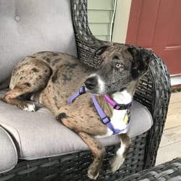
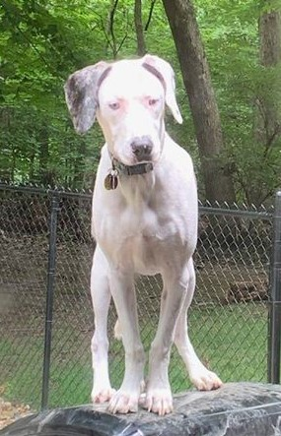

Mixed Breed  Deaf  Low Vision  25.9% Treeing Walker Coonhound  25.1% American Pit Bull Terrier  23.3% Doberman Pinscher  20.6% Miniature Pinscher | Mixed Breed  Normal Hearing  Normal Vision  24.0% Miniature Pinscher  22.6% Treeing Walker Coonhound  16.7% American Pit Bull Terrier  13.5% Doberman Pinscher  7.6% Chow Chow  5.5% American Staffordshire Terrier  10.1% Supermutt
55% SHARED DNA

