English 100
Bill McBride
Required Texts
Selections from the Hebrew Bible (any translation, preferably the King James) | 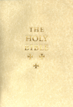
Sedgewick, Sedgwick, Edgar, eds. Key Concepts in Cultural Theory. Routledge 1999.
Joyce, James. A Portrait of the Artist as a Young Man [1916]. Viking | 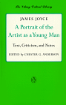
Beckett. Not I [1972] Pas Moi  Text found under course links. | 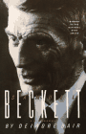
Salinger, J.D. Catcher in the Rye [1946].
Miller, Arthur. Death of a Salesman [1949]. Penguin | 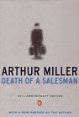
Albee, Edward. Who's Afraid of Virginia Woolf? [1962]. Signet
Lakoff, George & Mark Johnson. Philosophy in the Flesh : The Embodied Mind and Its Challenge to Western Thought. 1998, Basic Books. | 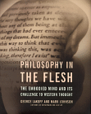
A chapter from Ishmael. Quinn, Daniel [1995], Bantam. | 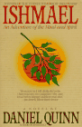
Other texts to be announced.

